***NAME : Himanshu Dixit***

***ENROLL NO. : B64178***

***BATCH : B10***

***SOFTWARE DEVELOPMENT FUNDAMENTAL LAB-I(15B17CI171) Assignment Sheet (WEEK-7 PHASE-2)***

***Lab A***

***1.*** *Write a function in c to find the missing value in an array. For example:*

*If array A= { 1, 2, 4, 6, 3, 7, 8} Missing value is 5*

*If A={1,2,4,5} Missing value is 3.*

***Solution:***

#include<stdio.h>

void missing(int a[100],int n)

{

int k=0;

for(int i=a[0];i<=a[n-1];i++)

{

if(i!=a[k])

{

printf("%d is missing number\n",i);

k--;

}

k++;

}

}

int main()

{

int a[100],n;

scanf("%d",&n);

for(int i=0;i<n;i++)

{

scanf("%d",&a[i]);

}

missing(a,n);

return 0;

}

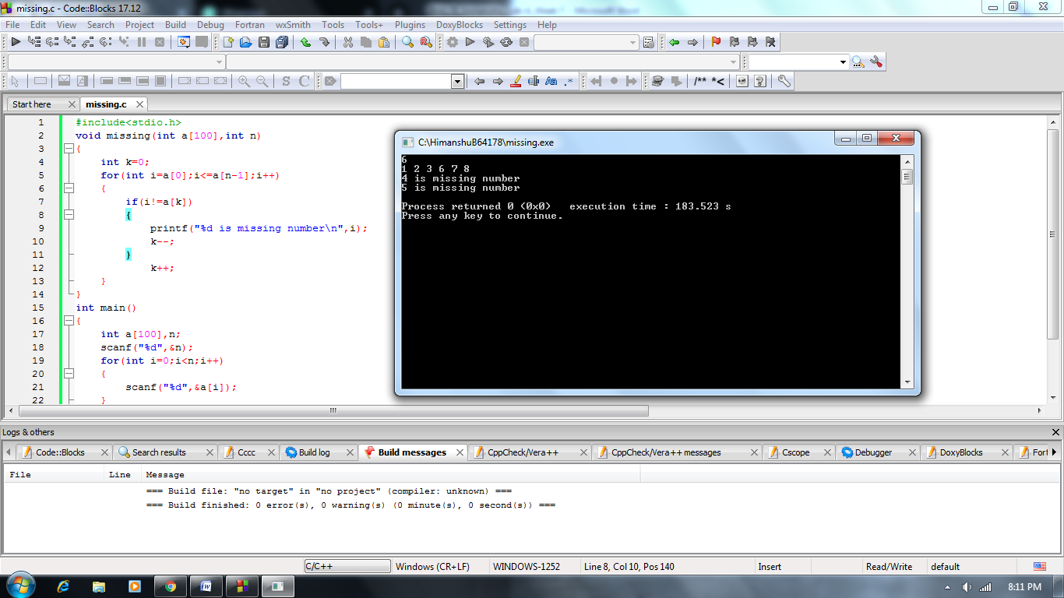

***2.*** *Write a C/C++ function “array_sort” which arranges the numbers of an array in  ascending order. Consider that the user will enter the number randomly for array in  the main function.*

***Solution:***

#include<stdio.h>

void arraysort(int a[100],int n)

{

int k;

for(int i=0;i<n;i++)

{

for(int j=i+1;j<n;j++)

{

if(a[i]>a[j])

{

k=a[j];

a[j]=a[i];

a[i]=k;

}

}

}

for(int i=0;i<n;i++)

printf("%d ",a[i]);

}

int main()

{

int a[100],n;

scanf("%d",&n);

for(int i=0;i<n;i++)

{

scanf("%d",&a[i]);

}

arraysort(a,n);

return 0;

}

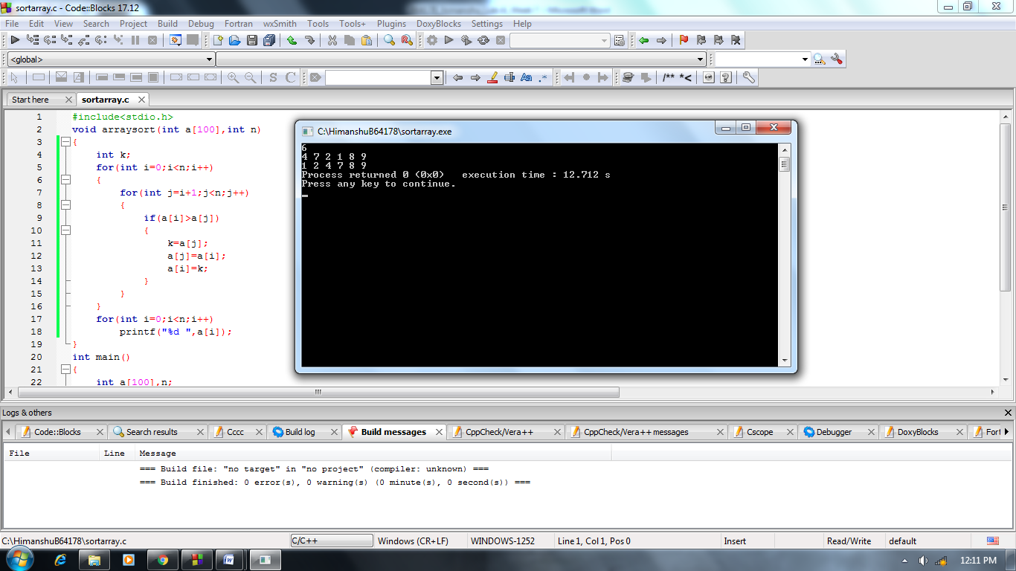

***3.*** *Write a program to find sum of digits of the number using Recursive Function.*

***Solution:***

#include<stdio.h>

int recsum(int n,int sum)

{

if(n==0)

return sum;

int a=n%10;

n=n/10;

sum=sum+a;

int s=recsum(n,sum);

return s;

}

int main()

{

int n,sum=0;

scanf("%d",&n);

int s=recsum(n,sum);

printf("%d",s);

return 0;

}

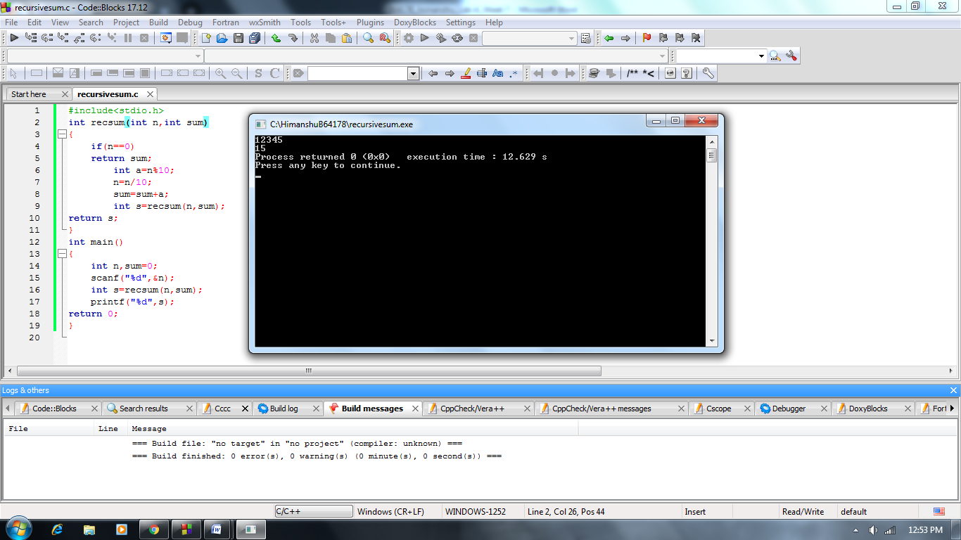

***4.*** *Write a program to read an integer number and print the reverse of that number using  recursion.*

***Solution:***

#include<stdio.h>

int recrev(int n,int rev)

{

if(n==0)

return rev;

int a=n%10;

n=n/10;

rev=rev*10+a;

int r=recrev(n,rev);

return r;

}

int main()

{

int n,rev=0;

scanf("%d",&n);

int r=recrev(n,rev);

printf("%d",r);

return 0;

}

